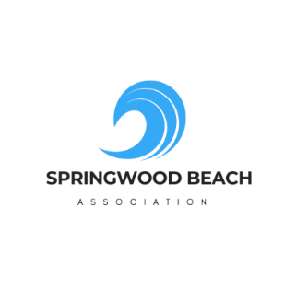 2025 Code of conduct of the SBA Member
As a member, I _______________________________ (print name) will respect these rules of conduct and make sure my family and guests will do the same.

According to the municipality’s rules, on the beach or the dock:
- No dogs are allowed.
- No BBQ or Fires are allowed.
- Alcohol is not permitted.
- Boats or Jet Skis are not allowed in the swimming area and should not be attached to the dock
- No one can stay on the beach after 11 pm.
To be respectful of each other:
- No diving or jumping off the dock.
- No intentional splashing of people sitting on the dock.
- No fishing off the dock.
- No throwing sand:
  - If a hole is dug in the sand, fill it before leaving the beach.
- Music is permitted, but if a member asks you to turn down the volume, be respectful and do so.
- No smoking of any kind (cigars, cigarettes, vapes, cannabis)
- Intoxication, verbal abuse, or harassment will not be tolerated.
- Bring back home any garbage.
  - No throwing of garbage in the water.
- Walkway should be kept clear:
  - Bicycles and trolleys used for kayaks and paddleboards must be kept outside the fence.
- No sitting, hanging, or playing on the fence.
- Always close the gate behind you.

Signature : ________________________________ Date : _________________________

